EXPERIMENT- 27
Do Cropping, Copying and Pasting Image inside another Image using OpenCV
Aim
To write a Python code to crop, copy, and paste a selected region from one image into another image using OpenCV image manipulation techniques.
Input Images
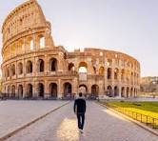
Code
import cv2
from google.colab.patches import cv2_imshow
from google.colab import files
uploaded=files.upload()
paths=list(uploaded.keys())
main_image=cv2.imread(paths[0])
paste_image=cv2.imread(paths[1])
if main_image is None or paste_image is None:
print("Error: Image not found")
else:
cropped_region=main_image[0:80,0:288]
paste_height,paste_width,_=paste_image.shape
main_image[0:80,0:288]=cv2.resize(cropped_region,(288,80))
print("Result Image")
cv2_imshow(main_image)
Output Image
Cropped and Pasted Image
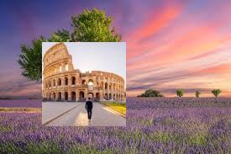
Result
Thus, cropping, copying, and pasting operations were successfully performed using OpenCV.

